+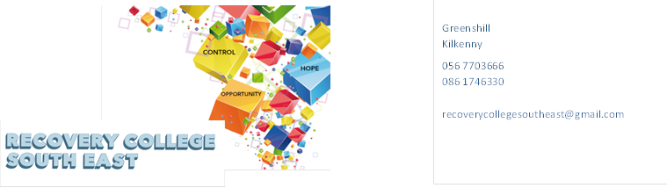
Website: www.recoverycollegesoutheast.com
Kilkenny Calendar of Events Autumn/Winter 2018
All our courses and workshops are co-produced and co-delivered with those who have lived experience in partnership with professional expertise, “the expert by experience working alongside the expert by profession”. Courses and workshops at the Recovery College South East are for everyone. Recovery College South East uses an educational approach to develop strengths, talents and personal resources.
VENUE | WORKSHOP NAME |  | DATES |  | TIME
September 2018
Recovery College South East.  (Kilkenny) | Growing towards Health and wellness ( 6 week workshop, one morning per week)  Calling all “green fingers” and those that have an interest but not necessarily the knowledge skills or experience in gardening. We would like your help in creating and developing our garden into an open space that reflects wellness and recovery, where the students of the college can sit, relax and enjoy.  This six week workshop will offer people an opportunity to explore the link between gardening nature, wellness and wellbeing, while having the practical elements of designing planting, sowing and digging. Be it sowing and minding your own flower pot, tending to a vegetable plot, or simply deciding where the garden seat will go.  The creation of a physical thing from your own work, that you can then use to nourish yourself, is a great boost to self-esteem that can’t be underestimated. |  | Every Monday 10th, 17th, 24th September and 1st, 8th and 15th October |  | 10am – 1.30pm
Recovery College South East.  (Kilkenny) | Co-Production (4 week workshop, 2 full days each week)  This series of workshops will give people the skills and knowledge required to design, develop, and deliver recovery education workshops in partnership with the Recovery College South East. Co-Production is working together, expert by expertise, working alongside expert by experience, bringing together the clinical experience and the lived experience to empower people through education on mental health challenges and addiction challenges. |  | Monday 10th, Tuesday 11th Monday ,17th and Tuesday 18th September |  | 10am – 4pm
Recovery College South East.  (Kilkenny) | Understanding Depression (4 week workshop, one half day each week) Depression goes beyond feelings of sadness or unhappiness and can deeply disrupt how we think, feel and live in our daily lives. Some people will have experiences which are not well-known features of depression. This workshop covers essential information about depression, how it is diagnosed and how it affects different people. We also look at the different tools for managing depression. This is a space to discuss your experiences and learn from others too. This workshop will explore the nature and experience of depression and consider its wide ranging impact on all aspects of life. We will reflect on diagnosis and medication as well as alternative practical steps which some people find helpful in managing this experience. |  | Every Wednesday, 19th, 26th 3rd and 10th October |  | 10am – 1.30pm
 | September 2018
Recovery College South East.  (Kilkenny) | Understanding Self Esteem ( two week workshop , one morning each week )  We believe that real self-esteem comes from a healthy respect for yourself and an understanding of what your role is in the world. Each week we will look at a different aspect of how you feel about yourself and how to build on that. Some of the topics covered: interactions with others, low and positive self-esteem and positive affirmations. We look at areas including; Your awareness of who you are, How you think and feel about your strengths and weaknesses. The expectations you place on yourself. Your awareness of what you want from your life. Do you accept yourself for who you are or not? How you view yourself in comparison to others, How you think and feel about what other people say about you. |  | Thursday 13th September and  Thursday 20th September |  | 10am – 1.30pm
Recovery College South East.  (Kilkenny) | Recovery Principles and Practice (Morning workshop)  Recovery Principles and Practice aims to bring an increased awareness to all staff in the Mental Health Services of the benefits of a recovery approach in practice. The training is built on incorporating the unique expertise that core stakeholders, service users, family members and service providers bring to the recovery process. |  | Wednesday 26th September |  | 10a – 1.30pm
Recovery College South East.  (Kilkenny) | Building my Self Confidence (Morning workshop)  Knowing yourself and having confidence in yourself is not only important but is helpful in living well. Focussing on inner confidence rather than behaviour, this course will share strategies that enable you to identify your strengths and qualities in order to live well and maintain your wellbeing. This workshop will focus on understanding the importance of self-confidence for wellbeing, how to build confidence. Discover how values and beliefs affect our confidence and explore ways to increase confidence. |  | Thursday 27th September |  | 10am – 1.30
October 2018
Recovery College South East.  (Kilkenny) | Understanding and Managing Anxiety ( Four week workshop one half day each week)  Everyone experiences periods of anxiety at some stage in their lives. We can feel tense, uncertain, fearful or nervous. Anxiety is a word used to describe these moments of discomfort. In this workshop we will look at how anxiety affects people in different ways - both emotionally and physically - and when these periods of unease, fear or worry affects your mental health. We will look at the different types of anxiety, it’s possible causes and how you can help manage these feelings. You will have the opportunity to discuss your own personal experiences whilst learning from others. This workshop will provide you with a safe space to discuss your concerns, find out about support, and self-help groups available in your community. | Every Tuesday 2nd, 9th, 16th and 23rd October |  | 10am – 1.30pm
Recovery College South East.  (Kilkenny) | 5 Ways to Wellness - (Morning Workshop)  Five ways to wellbeing is a set of 5 simple actions that each of us can bring into our everyday lives to improve wellbeing. This workshop will focus on Giving, Being Active, Learning, Taking Notice and Connecting. | Wednesday 10th October |  | 10.30am – 1pm
 | October 2018
Recovery College South East.  (Kilkenny) | Music for Mood –( Morning workshop)  Do you listen to music? Has it ever uplifted your mood? How does music influence or affect our mental health? This workshop will explore why some music can motivate us or sooth us and how we can use music as a wellness tool in our everyday lives. | Thursday 11th October |  | 10.30 – 1pm
Recovery College South East.  (Kilkenny) | Food for Mood- (Morning workshop)  This workshop will explore the connection between food and mental health and wellness. How true are the old sayings “An apple a day keeps the Doctor away” and “Your health is your wealth”? Simple tips and tools for eating right for your mental health. | Friday 19th October |  | 10.30 – 1pm
Recovery College South East.  (Kilkenny) | Understanding and Supporting Families  Meridan Family Programme –( 7 week evening workshop) (www.meridanfamilyprogramme.com)  Is someone in your family unwell from either a physical illness, mental health and /or addiction challenge and are you involved in supporting them? If yes, you may find this workshop beneficial to you. It will discuss the challenges people face when trying to support themselves as well as another person. It looks at communication in families. It includes tips and tools in how to make time for yourself and explore the role of the family member and the challenges this brings in everyday life. It will also give information on local support services and the opportunity to chat to and learn from others in similar situations. (The Meridan family programme is a programme which promotes the development of family sensitive mental health and addiction services.) | Every Monday 1st , 8th, 15th, 22nd October and 5th, 12th and 19th November |  | 7-9pm
Recovery College South East.  (Kilkenny) | WRAP – Level 1 (2 full days)  WRAP is for everybody. It is a tool to help us to achieve and maintain wellness and gain more control over our lives and the way we feel. It is designed to help us identify what works and what doesn’t work and how we can get better at staying well. | Wednesday 17th and Thursday 18th October |  | 10am – 4pm
Recovery College South East.  (Kilkenny) | Service User Involvement Learning and Development Workshop – (1 full day with a follow-up day to be decided with the group)  Service users and family members are central to the development of recovery orientated mental health services, as set out in National Policy, A vision for Change 2006, the National Drugs Strategy 2009-2016, the Judgment Support Framework 2017, Best Practice Guidance for Mental Health 2017 and most recently the development of the National Framework for Recovery in Mental Health 2018-2020. This workshop will explore the meaningful involvement of service users and family members at individual level, service level and strategic level. As part of this workshop, you will be asked to develop your own action plan to support increased service user participation in your area. | Monday 22nd October |  | 10am – 4pm
November 2018
Recovery College South East.  (Kilkenny) | Understanding alcohol and drug use (four week workshop one half-day each week)  This workshop is for people who are curious or concerned about their own alcohol or drug use, or are concerned about the alcohol or drug use of someone they care about. It is also for people who work in services who want to support people more confidently around alcohol and drug issues. We will be exploring this subject in a sensitive and non-judgemental way where students don’t need to share their personal experience if they don’t feel comfortable. We will look at some of the reasons why people use drugs or alcohol, the range of ways that people use alcohol or drugs at different times, how people can decide whether their use of alcohol or drugs is a problem or not, how people have taken back control of their lives from alcohol and drugs. | Every Monday 5th, 12th, 19th and 26th November |  | 10am – 1.30pm
Recovery College South East.  (Kilkenny) | It’s Good to Talk – Communication Skills – positive relationships (Morning workshop)  Being able to talk about our mental health has been proved to be beneficial for emotional wellbeing. The course will look at the barriers as to why we might sometimes find it difficult to talk as well as exploring the benefits and positive effects of talking to someone about our mental and emotional health and wellbeing. | Tuesday 6th November |  | 10am – 1.30pm
Recovery College South East.  (Kilkenny) | Understanding Self Harm -( Full Day workshop)  Do you self harm, or do you know someone who self harms?  Life can at times be hard to cope with, especially if you have experienced traumatic events. Sometimes, it feels that the only way to feel better or express how you feel is to hurt yourself in some way. What starts as a private act can become a habit which can get out of control. There are lots of myths about self-harm because it is something that many people find difficult to understand. This can make it a taboo, embarrassing subject that is uncomfortable to admit and address. The reality is that many more people self-harm than you think. This workshop aims to give you confidence to think and talk about this subject and to understand the very individual experience of it. | Wednesday 7th November |  | 10am – 4pm
Recovery College South East.  (Kilkenny). | Learning Self Compassion and Kindness for myself –(Morning workshop)  Do you ever feel cut off from others and feel like other people are somehow better able to cope? Is it difficult to find time to look after yourself, do you tend to criticise and judge yourself more harshly than you would others? Do you concentrate more on mistakes and failures rather than your strengths and successes? There is another way. Developing self compassion and learning to be kinder to ourselves is possible for everyone. It can help us to discover who we are even in times of difficulty. This workshop will explore what self compassion is and how to overcome barriers to developing it. | Thursday 8th November |  | 10am – 1.30pm
 | November 2018
Recovery College South East.  (Kilkenny) | Good Stress/Bad Stress -(Morning workshop)  Many people believe that all stress is bad, but you may have heard that there's "good stress" and "bad stress." Do you know what people mean by that? We rarely hear people say, "I'm really feeling stressed—isn't that great? These days, many aspects of life can feel highly stressful, affecting our ability to think clearly, to relax or to look after ourselves. Whilst small amounts of stress can prompt us to action, too much stress over a long period of time can seriously affect our emotional and physical health. This introductory workshop supports you to look at the causes of your stress, giving you practical activities and suggestions that can help you to reduce the impact on your life. | Wednesday 14th November |  | 10am – 1.30pm
Recovery College South East.  (Kilkenny) | Understanding and Managing Anger (2 week workshop – one morning each week)  We all feel angry sometimes; it is part of being human. It is a natural response to feeling attacked, offended, deceived or frustrated. Anger can be useful but it can also become a problem when it harms us or the people around us. Being angry isn’t a problem in itself; it’s how we deal with it so that it does not become damaging to our health and our relationships. We may feel as though there is little that can be done to control our anger, but there are things that we can do that can make a difference. In this course we will explore more about how anger works and factors which can make it worse, learn ways to recognise our anger signs, think about how anger affects both body and mind, look at basic tools to manage our anger. | Thursday 15th and Thursday 22nd November |  | 10am – 1.30pm
Recovery College South East.  (Kilkenny) | Coping with Christmas (Morning workshop)  How to thrive, not just survive the Holiday Season. Christmas is a time of year that has come to mean many different things for different people, but often it’s a difficult time with the family and financial problems it can bring. Whatever our spiritual background and however we feel about Christmas, we are surrounded by it! In this half day workshop we will support each other in looking at how we may be affected by the different aspects of the festival, including: personal values, money worries, relationships, loss, eating/ drinking too much and facing the New Year, and developing a personal plan to help cope with Christmas. | Wednesday 21st November |  | 10am – 1.30pm
Recovery College South East.  (Kilkenny) | Assertiveness skills two-week workshop (one half day per week)  We can all sometimes find it hard to say what we really mean or find it difficult to say no to certain things. If we are struggling with mental health difficulties or other stresses it can be even harder. Assertiveness is a way of communicating that allows us to express our point of view and state our needs clearly. At the same time, assertive communication respects the needs of others. In these sessions students will have the chance to gain assertiveness skills. We will explore and learn What assertive communication is? The different ways we can communicate and behave. What assertive behaviour looks like? Tools and techniques for assertive behaviour, including saying no and giving and receiving feedback. Students will have the opportunity to identify situations in their own lives where they would like to be assertive and then plan and practice assertive communication in a supportive environment. | Wednesday 28th November and Wednesday 5th December |  | 10am – 1.30 pm

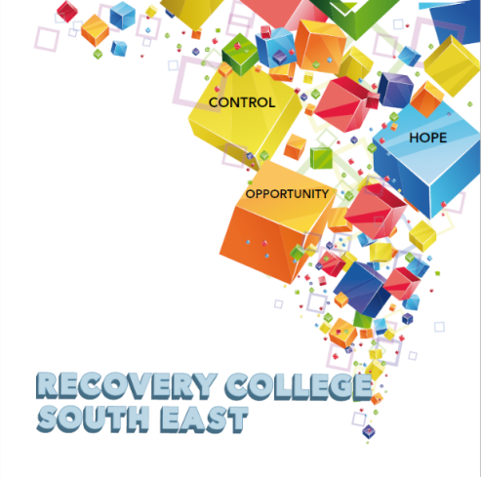

Greenshill
Kilkenny
056 7703666
086 1746330

recoverycollegesoutheast@gmail.com

Recovery College South East Enrolment Form
Course title | Commencement date

PLEASE COMPLETE USING BLOCK CAPITAL LETTERS
Surname:

First name(s)

Address:

Telephone: | Mobile | Home/Work
Contact Details in Case of Emergency: | Name | Number
Email:

All our workshops are based around discussion with some written exercises at your own discretion.

All our Workshops are free however, there is an enrolment fee of €5 per semester, per student. Our workshops are also open to everyone.

Are you happy for us to keep you informed by email, post or text about the Recovery College South East or future courses? ( Please tick this box if yes. )

Student Signature _________________________________ Date _________________________
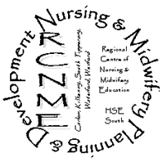
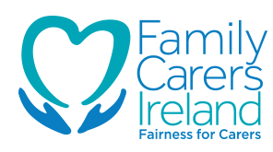
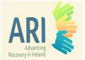
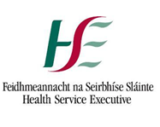
Recovery is moving on, achieving and learning, being the best and the best that I can be with confidence” Mental Health Discussion Group Clonmel 2013
