+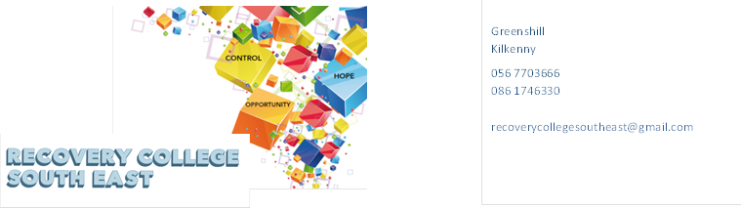
Website: www.recoverycollegesoutheast.com
Recovery College South East
South Tipperary
Recovery Education Programme January to March 2024

You are invited to join us in our new Recovery Education Programme for Spring 2024.
All our courses and workshops are co-produced and co-delivered with those who have lived experience in partnership with professional expertise, “the expert by experience working alongside the expert by profession”.
Courses and workshops at the Recovery College South East are for everyone and are free.

This year, we are delighted to be able to offer integrated/hybrid workshops which means you have the option of attending some of the workshops in person or join online from home as specified on the timetable. It is important if you choose the online option, that you indicate your preference on the enrolment form so the link can be
sent to your email.

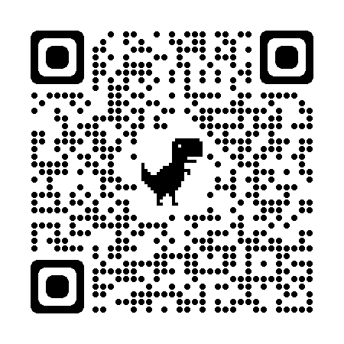
(For more detailed information on the workshops, please go to the Workshop Section of our Website – www.recoverycollegesoutheast.com.) You can scan our QR code for quick access to our website
- Complete the attached enrolment form and email it to the Recovery College South East at enrolrecoverycollegesoutheast@gmail.com or
- Phone us on 086 1746330 to enrol

January 2024
VENUE | WORKSHOP NAME | DATES | TIME
Community Mental Health Centre  Glenconnor Road  Clonmel  (in-house only) | WRAP – Level 1 (4 week Morning workshop)  WRAP is for everybody. WRAP helps you to get to know yourself. WRAP is your personal plan which you have put in place in the good times to remind you and guide you through the bad times. WRAP helps to achieve and maintain wellness and gain more control over our lives and the way we feel. It is developed to help us identify what works and what doesn’t work and how we can get better at staying well. See workshop description – page 5.  This is a four-hour workshop each week and lunch will be provided | Tuesday 16th, 23rd and 30th Jan, 6th Feb | 10am – 2pm
South Tipperary Involvement Centre, Place 4U  Gladstone Street  Clonmel  (In-house Workshop) | Writing Group  This group is open to anyone, regardless of whether you are an experienced writer, a beginner or even just curious about creative writing. So, come along, join the group and give it a go. Looking forward to meeting you. See workshop description – page 5 | 3rd Wednesday of the month  24th Jan | 3pm – 4pm
Carrig Óir  Cashel  (in-house only) | WRAP – Level 1 (4 week Morning workshop)  WRAP is for everybody. WRAP helps you to get to know yourself. WRAP is your personal plan which you have put in place in the good times to remind you and guide you through the bad times. WRAP helps to achieve and maintain and wellness and gain more control over our lives and the way we feel. It is developed to help us identify what works and what doesn’t work and how we can get better at staying well. See workshop description – page 5  This is a four-hour workshop each week and lunch will be provided | 24th, 31st Jan & 7^{th &} 14th Feb | 10am – 2pm
Recovery College South East  Online – Zoom | Support Group for people who live with Anxiety (Last Monday of the month)  This peer support group will give you an opportunity to share openly and safely your personal experience of anxiety, what worked well for you, the day-to-day challenges of living with anxiety, a chance to share your knowledge with and also learn coping tips and tools from others who have experience of anxiety. Workshop description page 4 | Last Monday of the month  29th January | 2.30pm
February 2024
VENUE | WORKSHOP NAME | DATES | TIME
South Tipperary Involvement Centre  Place 4U  Gladstone Street  (In-house Workshop) | Writing Group  This group is open to anyone, regardless of whether you are an experienced writer, a beginner or even just curious about creative writing. So, come along, join the group and give it a go. Looking forward to meeting you. See workshop description – page 5 | 3rd Wednesday  Of the month | 3pm – 4pm
Community Mental Health Centre  Glenconnor Road  Clonmel  (in-house only) | Building our Self-confidence (Morning Workshop)  How we view ourselves shapes and determines a good deal of our behaviour.  If we want to change how we feel about ourselves and how we behave, we need to address issues in respect of our own self-esteem and confidence.  This workshop defines what self-confidence and self-esteem are and details ways to begin improving our confidence and self-esteem Page 4 | Tuesday 13th February | 10:00am to 12:30pm
Community Mental Health Centre  Glenconnor Road  Clonmel  (in-house only) | Feel The Fear – 4 Week Morning Workshop  Everyone has fears, they run through our lives. Susan Jeffers’ book shows us how to break down our fears, and work through our fears to a resolution. As she says, “Feel the Fear, and do it anyway.”  See workshop description Pg 5 | Tuesday  Feb 20th 27th and 5^{th &} 12th March | 10:00 - 12:30
Carrig Óir  Cashel  (in-house only) | Loneliness, Isolation and Reconnecting  (3-week Morning workshop)  Many people are affected by a feeling of loneliness and isolation. Recent and up to date studies show the negative effects Loneliness and isolation can have on our overall health and wellbeing.  See workshop description – Page 4 | Wednesday 21st &28th February & 6th March | 10:00 – 12:30
MARCH 2024
VENUE | WORKSHOP NAME | DATES | TIME
South Tipperary Involvement Centre. Place 4U  Gladstone Street  Clonmel  (in-house only) | Writing Group  This group is open to anyone, regardless of whether you are an experienced writer, a beginner or even just curious about creative writing. So, come along, join the group and give it a go. Looking forward to meeting you. See workshop description – page 5 | Third Wednesday of the month  20th March | 3pm – 4pm
Carrig Óir  Cashel  (in-house only) | Understanding and Living with Hearing Voices.  (Morning Workshop)  The experience of hearing voices can differ from person to person. The aim of this workshop is to gain a better understanding of the common nature of voice hearing, to explore and share ideas for managing and living well with hearing voices. See workshop description – 4 | 13th March | 10:00 – 12:30
Carrig Óir  (in-house only) | Positive Thinking (Morning workshop)  This workshop will help participants identify patterns of negative thinking and to acquire skills to help develop positive thinking. See workshop description – page 4 | 20th March | 10:00 – 12:30
Community Mental Health Centre  Glenconnor Road  Clonmel  (in-house only) | Goal Setting  The aim of this Workshop Is to help participants identify specific goals and develop effective strategies to achieve these goals. See workshop description Page 5 | 19th March | 10:00 – 12:30
Carrig Óir  Cashel  (in-house only) | Self-Belief (Morning workshop)  Self-belief is a person’s belief in their ability to complete tasks and to achieve their goals (Bandura, 1995). This workshop will explore the term self-belief and how it can influence your life in many ways. It will also look at different ways of how to enhance your level of self-belief. See workshop description – page 4. | 27th March | 10:00 – 12:30

Workshop Descriptions
Workshop Title | Description
Building our Self Confidence | How we view ourselves shapes and determines a good deal of our behaviour.  If we want to change how we feel about ourselves and how we behave, we need to address issues in respect of our own self-esteem and confidence.  This workshop defines what self-confidence and self-esteem are and details ways to begin improving our confidence and self-esteem
Loneliness, Isolation and Reconnecting  (3 week workshop) | Many people are affected by a feeling of loneliness and isolation. Recent and up to date studies show the negative effects Loneliness and isolation can have on our overall health and wellbeing.  The aims of this workshop are:  - To explore how loneliness and isolation impacts on all aspects of life  - To share ideas on how loneliness and isolation can be positively addressed  - To identify practical ways of reconnecting with society and making new connections.  - To explore what’s available in your local community both online and in person.
Positive Thinking  (Morning Workshop) | The power of positive thinking is remarkable.  Developing a positive attitude can transform you whole life for the better.  The aim of this workshop is to:  - Explore ways we practice positive thinking ourselves  - Provide practical tips and tools to maintain positive thinking patterns
Self Belief  (Morning Workshop) | Self-belief is a person’s belief in their ability to complete tasks and to achieve their goals (Bandura, 1995). This 2-part workshop will explore the term self-belief and how it can influence your life in many ways. It will also look at different ways of how to enhance your level of self-belief.  The aim of this workshop is to:  - Discuss the term self-belief ad explore what it means to you  - Gain an understanding of how self-belief can influence your sense of self and identity  - Explore skills and strategies which help develop self-belief
Support group for people who live with Anxiety | This peer support group will give you an opportunity to share openly and safely your personal experience of anxiety, what worked well for you, the day-to-day challenges of living with anxiety, a chance to share your knowledge with and also learn coping tips and tools from others who have experience of anxiety.  This group is open to everyone and will meet the last Monday of every Month from 10am-11am.
Understanding and Living with Hearing Voices  (Morning workshop) | The experience of hearing voices can differ from person to person. Our uniqueness as individuals is often reflected in the voices people experience. These voices can have distinct content, identities, meaning and impact on the person experiencing them.  The aim of this workshop is:  - To gain a better understanding of the common nature of voice hearing,  - To explore the different individual experiences within the group  - To discuss and share ideas for managing and living well with hearing voices
WRAP – Level 1  (4 Week Workshop)  To get the full benefit from this series of workshops, it is recommended that you attend all sessions. | WRAP is for everybody. WRAP helps you to get to know yourself. WRAP is your personal plan which you have put in place in the good times to remind you and guide you through the bad times. WRAP helps to achieve and maintain  wellness and gain more control over our lives and the way we feel. It is developed to help us identify what works and what doesn’t work and how we can get better at staying well.
Writing Group | Finding it hard to fill in your day? Looking for an activity or new interest? Why not join our online creative writing group? It’s fun, it’s entertaining and it is also a great way to meet new friends.  This group is open to anyone, regardless of whether you are an experienced writer, a beginner or even just curious about creative writing. This is a great way to express yourself and what may be going on for you in your world.  So, come along, join the group and give it a go. Looking forward to meeting you.
Positive Thinking | The power of positive thinking is remarkable.  Developing a positive attitude can transform you whole life for the better.  The aim of this workshop is to:  - Explore ways we practice positive thinking ourselves.  Provide practical tips and tools to maintain positive thinking patterns
Feel The Fear  (4 week Workshop) | How to turn your fear and indecision into confidence and action.  Fear – What is it for you? Fear seems to be epidemic in our society, we fear beginning; we fear ending; we fear changing; we fear staying stuck. Whatever your fear, this 4-week workshop will give you the insight and tools to vastly improve your ability to handle any given situation. You will move from a place of pain to a place of power, energy, and excitement.  The aim of this workshop is to:  - Understand the concept of fear.  - To be able to let go negative programming.  - Tools to build self-esteem and assertiveness.  - Believe in ourselves and connect with our inner strength.

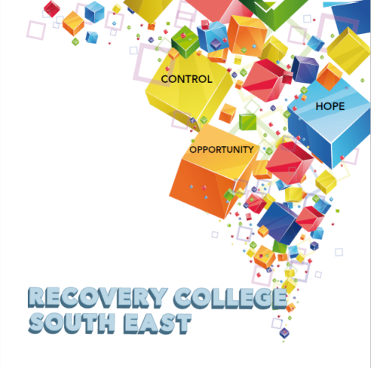

Greenshill
Kilkenny
056 7703666
086 1746330

recoverycollegesoutheast@gmail.com

Enrolment Form
Course title | Commencement date | In-house or Online (Zoom)  Please tick your preference below
 |  | In-house | Online (Zoom)
 |  | In-house | Online (Zoom)
 |  | In-house | Online (Zoom)

PLEASE COMPLETE USING BLOCK CAPITAL LETTERS
Surname:

First name(s)

Address:

Telephone: | Mobile | Home/Work
Email:
Contact Details in Case of Emergency: | Name | Number
Where did you hear about the Recovery College
Please tick the box that best describes you | Service User/Lived Experience_____________________________________  Family Member/Carer____________________________________________  Service Provider (Area of Work) __________________________________  _________________________________________________________________  Other (Please specify)/Prefer Not to Say____________________________________________  __________________________________________________________________
All our workshops are based around discussion and group work. Pen and paper would be helpful to have to hand for participants.
All our Workshops are free of charge.
Are you happy for us to contact you periodically by email, post or text about different events, workshops, surveys in relation to the Recovery College South East? (Please tick this box if yes.)

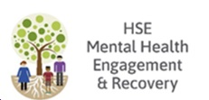
Student Signature _________________________________ Date _________________________
Recovery is moving on, achieving and learning, being the best and the best that I can be with confidence” Mental Health Discussion Group Clonmel 2013

