+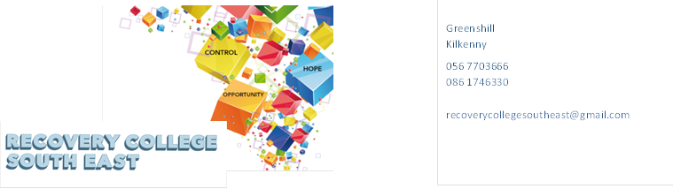
Website: www.recoverycollegesoutheast.com
Recovery College South East
South Tipperary
Recovery Education Programme April to June 2024

You are invited to join us in our new Recovery Education Programme for Spring 2024.
All our courses and workshops are co-produced and co-delivered with those who have lived experience in partnership with professional expertise, “the expert by experience working alongside the expert by profession”.
Courses and workshops at the Recovery College South East are for everyone and are free.

This year, we are delighted to be able to offer integrated/hybrid workshops which means you have the option of attending some of the workshops in person or join online from home as specified on the timetable. It is important if you choose the online option, that you indicate your preference on the enrolment form so the link can be
sent to your email.

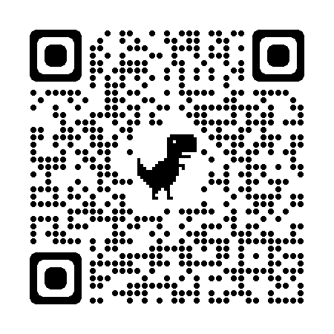
(For more detailed information on the workshops, please go to the Workshop Section of our Website – www.recoverycollegesoutheast.com.) You can scan our QR code for quick access to our website
- Complete the attached enrolment form and email it to the Recovery College South East at enrolrecoverycollegesoutheast@gmail.com or
- Phone us on 086 1746330 to enrol

April 2024
VENUE | WORKSHOP NAME | DATES | TIME
Clonmel Mental Health Centre  Glenconnor Road  Clonmel  E91 XT20  (in-house only)  . | Personal Development Programme (6 weeks)  To get the full benefit from this series of workshops, it is recommended that you attend all sessions.  - Self-Awareness  The aim of this session is to develop an understanding of self-awareness and its benefits for everyday living.  - Developing Positive Thinking  The aim of this session is to help identify patterns of negative thinking and to acquire skills to help develop positive thinking.  - Building our Self –Confidence and Self Belief  The aim of this session is to define and discuss self-confidence and belief in self, and to develop practical ways for building their own self-belief.  - Assertiveness  The aim of this session is to enhance understanding of what assertiveness is and to practice assertiveness skills.  - Effective communication  The aim of this session is to explore the concept of communication and the role it plays in your life and to develop effective communication skills through exploring a range of tips and tools.  - Maintaining Motivation  The aim of this session is to explore motivation and identify effective strategies to increase and maintain a high level of motivation.  Reflective Session  Delivered 4-6 weeks after completion of the programme, to check in with the Group and revisit areas of learning. | Tuesday 2nd, 9th, 16th, 23rd & 30th April & 7th May | 10am – 1pm
South Tipperary Involvement Centre, Place 4U  Gladstone Street  Clonmel  E91 HK51  (In-house Workshop) | Writing Group  This group is open to anyone, regardless of whether you are an experienced writer, a beginner or even just curious about creative writing. So, come along, join the group and give it a go. Looking forward to meeting you. See workshop description – page 5 | Wednesdays | 3pm – 4pm
Carrig Óir  Cashel  E25 F865 | Personal Development Programme (6 weeks)  To get the full benefit from this series of workshops, it is recommended that you attend all sessions.  - Self-Awareness  The aim of this session is to develop the understanding of self-awareness and its benefits for everyday living.  - Developing Positive Thinking  The aim of this session is to identify patterns of negative thinking and to acquire skills to help develop positive thinking.  - Building our Self –Confidence and Self Belief  The aim of this session is to define and discuss self-confidence and belief in self, and to develop practical ways for building their own self-belief.  - Assertiveness  The aim of this session is to enhance understanding of what assertiveness is and to practice assertiveness skills.  - Effective communication  The aim of this session is to explore the concept of communication and the role it plays in your life and to develop effective communication skills through exploring a range of tips and tools.  - Maintaining Motivation  The aim of this session is to explore motivation and identify effective strategies to increase and maintain a high level of motivation.  Reflective Session  Delivered 4-6 weeks after completion of the programme, to check in with the Group and revisit areas of learning. | 17th, 24th, April & 1st, 8th,15th & 22nd May | 10am – 1pm
May 2024
VENUE | WORKSHOP NAME | DATES | TIME
South Tipperary Involvement Centre  Place 4U  Gladstone Street  E91 HK51  (In-house Workshop) | Writing Group  This group is open to anyone, regardless of whether you are an experienced writer, a beginner or even just curious about creative writing. So, come along, join the group and give it a go. Looking forward to meeting you. See workshop description – page 5 | Wednesdays | 3pm – 4pm
Community Mental Health Centre  Glenconnor Road  Clonmel  E91 XT20  (In house workshop) | Learning Self-Compassion and Kindness to Myself  Do you ever feel cut off from other and feel like other people are somehow better able to cope? Is it difficult to find time to look after yourself, do you tend to criticise and judge yourself more harshly than you would others? Do you concentrate more on mistakes and failures rather than your strengths and successes? Developing self-compassion and learning to be kinder to ourselves is possible for everyone. This workshop will explore what self-compassion is and how to overcome barriers to developing it. | 14th May | 10:00am to 12:30pm
Community Mental Health Centre  Glenconnor Road  Clonmel  E91 XT20  ( In house workshop) | Understanding and Managing Anger  What is Anger? Why do we feel it? Does Anger affect your wellbeing and quality of life?  Anger is a natural powerful emotion that we all experience from time to time. However unchecked, it can impact negatively in our lives.  The aim of this workshop:  - Discuss how to manage and be in control during moments of anger so that you can live well and ensure your wellbeing during those moments.  - Explore what anger is and its effects.  - Recognise our own anger cycle and identify strategies to work with.  - Look at the process of anger and ways of truly dealing with physical and emotional responses.  - Recognise the feelings and thoughts that are hidden behind our anger.  - Understand the importance of effective communication when dealing with challenging situations will also be explored. | 28th May | 10:00 - 12:30
Carrig Óir  Cashel  E25 F865 | Food & Mood  This workshop will explore the connection between food and mental health and wellness.  How true are the old sayings “An apple a day keeps the doctor away” and “Your health is your wealth”?  Simple tips and tools for eating right for your mental health. | 29th May | 10:00 – 12:30
June 2024
VENUE | WORKSHOP NAME | DATES | TIME
South Tipperary Involvement Centre. Place 4U  Gladstone Street  Clonmel  E91 HK51 | Writing Group  This group is open to anyone, regardless of whether you are an experienced writer, a beginner or even just curious about creative writing. So, come along, join the group and give it a go. Looking forward to meeting you. See workshop description – page 5 | Wednesday | 3pm – 4pm
Community Mental Health Ctr  Glenconnor Road  Clonmel  E91 XT20 | Understanding and Managing Anxiety  Everyone experiences periods of anxiety at some stage in their lives. We can feel tense, uncertain, fearful or nervous. Anxiety is a word used to describe these moments of discomfort.  Anxiety can change from something everyone experiences in a mild form, to something which is persistent, excessive or over-whelming. It can begin to interfere with many aspects of your life - from confidence, to physical wellbeing and engagement in basic or complex activities of living  The aim of this four-part workshop is:  - To explore the facts around anxiety  - To explore the causes and symptoms associated with anxiety  - To look at how anxiety affects people in different ways –  - To explore practical and effective ways of managing and living with anxiety. | 4th, 11th, 18th & 25th June | 10:00 – 12:30
Carrig Óir  Cashel  E25 F865 | Understanding and Managing Anxiety  Everyone experiences periods of anxiety at some stage in their lives. We can feel tense, uncertain, fearful or nervous. Anxiety is a word used to describe these moments of discomfort.  Anxiety can change from something everyone experiences in a mild form, to something which is persistent, excessive or over-whelming. It can begin to interfere with many aspects of your life - from confidence, to physical wellbeing and engagement in basic or complex activities of living  The aim of this four-part workshop is:  - To explore the facts around anxiety  - To explore the causes and symptoms associated with anxiety  - To look at how anxiety affects people in different ways –  - To explore practical and effective ways of managing and living with anxiety. | 5th, 12th, 19th & 26th June | 10:00 – 12:30

Workshop Descriptions
Workshop Title | Description
Learning Self Compassion and Kindness to myself (Morning workshop) | Do you ever feel cut off from other and feel like other people are somehow better able to cope? Is it difficult to find time to look after yourself, do you tend to criticise and judge yourself more harshly than you would others? Do you concentrate more on mistakes and failures rather than your strengths and successes? Developing self-compassion and learning to be kinder to ourselves is possible for everyone. This workshop will explore what self-compassion is and how to overcome barriers to developing it.
Personal Development Programme (8 weeks)  To get the full benefit from this series of workshops, it is recommended that you attend all sessions. | - Introduction to Personal Development  The aim of this session is to explore the components of personal development and how it can benefit us in achieving our goals in life.  - Self-Awareness  The aim of this session is to develop the participants’ understanding of self-awareness and its benefits for everyday living.  - Developing Positive Thinking  The aim of this session is to help participants identify patterns of negative thinking and to acquire skills to help develop positive thinking.  - Building our Self –Confidence and Self Belief  The aim of this session is to define and discuss self-confidence and belief in self, to empower participants to develop practical ways for building their own self-belief.  - Assertiveness  The aim of this session is to enhance participants’ understanding of what assertiveness is and to practice assertiveness skills.  - Effective communication  The aim of this session is to explore the concept of communication and the role it plays in your life and to develop effective communication skills through exploring a range of tips and tools.  - Maintaining Motivation  The aim of this session is to help participants understand motivation and identify effective strategies to increase and maintain a high level of motivation.  - Self-care and Wellbeing  The aim of this session is to enable participants to understand what wellbeing is and to provide participants with practical self- care tips and tools to be able to manage and reduce stress in their day to day working and personal life.  Reflective Session  Delivered 4-6 weeks after completion of the programme, to check in with the Group and revisit areas of learning.
Understanding and Managing Anxiety  ( Four week workshop )  To get the full benefit from this series of workshops, it is recommended that you attend all sessions. | Everyone experiences periods of anxiety at some stage in their lives. We can feel tense, uncertain, fearful or nervous. Anxiety is a word used to describe these moments of discomfort. Anxiety can change from something everyone experiences in mild forms, to something which is persistent, excessive or over-whelming. It can begin to interfere with many aspects of your life – from confidence, to physical wellbeing and engagement in basic or complex activities of living.  The aim of this four-part workshop is:  - To explore the facts around anxiety  - To explore the causes and symptoms associated with anxiety  - To look at how anxiety affects people in different ways –  - To explore practical and effective ways of managing and living with anxiety.
Understanding and Managing Anger  (Morning workshop) | What is Anger? Why do we feel it? Does Anger affect your wellbeing and quality of life?  Anger is a natural powerful emotion that we all experience from time to time. However unchecked, it can impact negatively in our lives.  The aim of this workshop:  - Discuss how to manage and be in control during moments of anger so that you can live well and ensure your wellbeing during those moments.  - Explore what anger is and its effects.  - Recognise our own anger cycle and identify strategies to work with.  - Look at the process of anger and ways of truly dealing with physical and emotional responses.  - Recognise the feelings and thoughts that are hidden behind our anger.  - Understand the importance of effective communication when dealing with challenging situations will also be explored.
Writing Group | Finding it hard to fill in your day? Looking for an activity or new interest? Why not join our online creative writing group? It’s fun, it’s entertaining and it is also a great way to meet new friends.  This group is open to anyone, regardless of whether you are an experienced writer, a beginner or even just curious about creative writing. This is a great way to express yourself and what may be going on for you in your world.  So, come along, join the group and give it a go. Looking forward to meeting you.
Food & Mood | This workshop will explore the connection between food and mental health and wellness.  How true are the old sayings “An apple a day keeps the doctor away” and “Your health is your wealth”?  Simple tips and tools for eating right for your mental health.

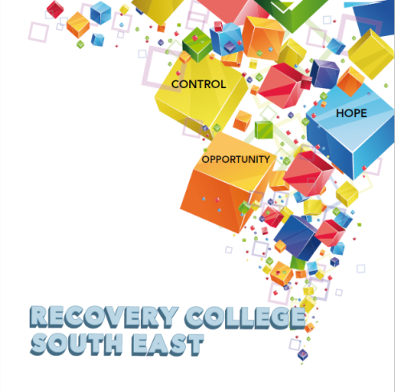

Greenshill
Kilkenny
056 7703666
086 1746330

recoverycollegesoutheast@gmail.com

Enrolment Form
Course title | Commencement date | In-house or Online (Zoom)  Please tick your preference below
 |  | In-house | Online (Zoom)
 |  | In-house | Online (Zoom)
 |  | In-house | Online (Zoom)

PLEASE COMPLETE USING BLOCK CAPITAL LETTERS
Surname:

First name(s)

Address:

Telephone: | Mobile | Home/Work
Email:
Contact Details in Case of Emergency: | Name | Number
Where did you hear about the Recovery College
Please tick the box that best describes you | Service User/Lived Experience_____________________________________  Family Member/Carer____________________________________________  Service Provider (Area of Work) __________________________________  _________________________________________________________________  Other (Please specify)/Prefer Not to Say____________________________________________  __________________________________________________________________
All our workshops are based around discussion and group work. Pen and paper would be helpful to have to hand for participants.
All our Workshops are free of charge.
Are you happy for us to contact you periodically by email, post or text about different events, workshops, surveys in relation to the Recovery College South East? (Please tick this box if yes.)

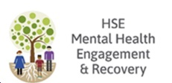
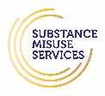
Student Signature _________________________________ Date _________________________
Recovery is moving on, achieving and learning, being the best and the best that I can be with confidence” Mental Health Discussion Group Clonmel 2013

